TASK 1

Basic Operations Of Power BI



Step 1:Open Power BI and use the **Get Data** option on the toolbar to import data from your local storage.

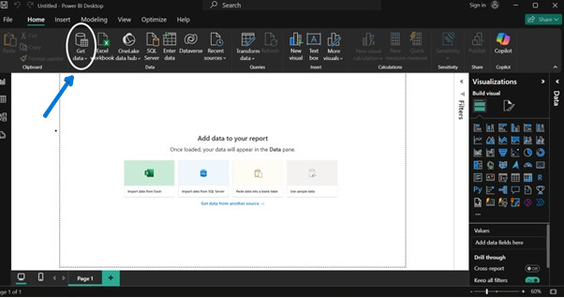

Step 2: After clicking on **Get Data**, select the **Text/CSV** option from the available data source formats to load the CSV file from your local storage.

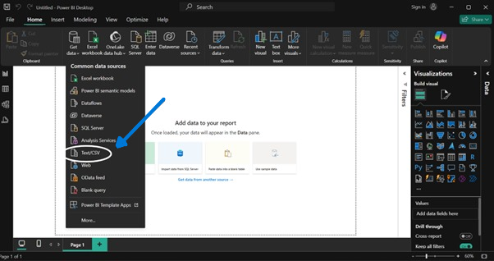

Step 3: Locate and select the required file from your local computer storage, then open it.

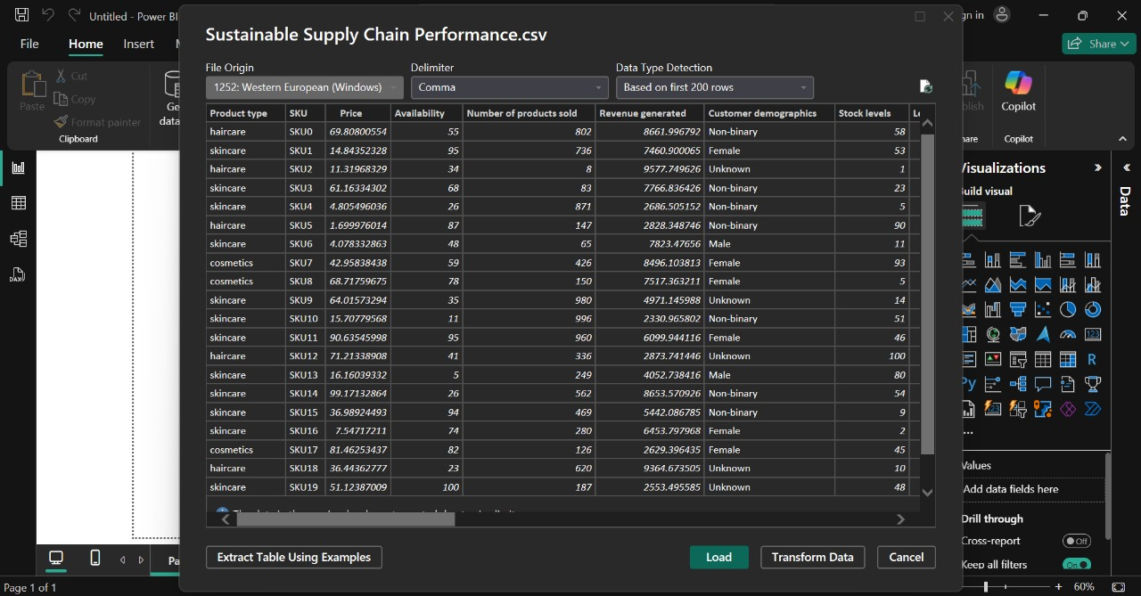

Step 4: After loading the CSV file, select the Transform Data option to clean and refine the dataset by addressing issues such as missing values or duplicates, and by removing unnecessary rows or columns to reorganize the data.

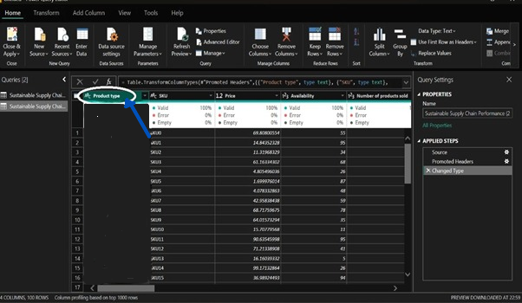

Step 5: To eliminate empty rows from the dataset, choose the Remove Blank Rows option from the menu.

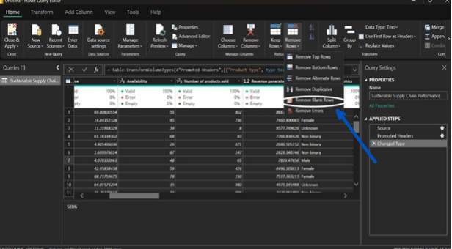

Step 6: To create additional tables, right-click on the existing data on the left side and select the **DUPLICATE** option.

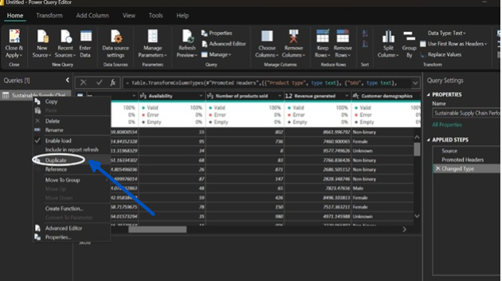

Step 7: Here are some tables that can be created by clicking on Transform Data and selecting the Duplicate option.

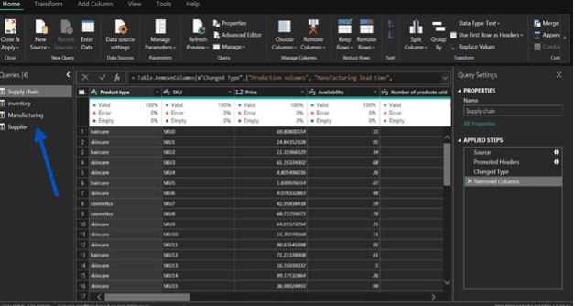

Step8: Once the data transformation task is complete, click on the Close and Apply button to load the data for further processing.

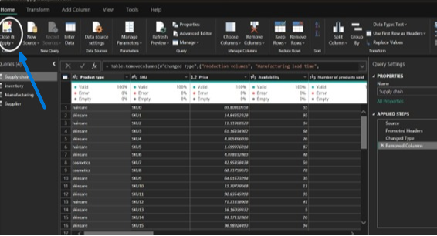

Step9: After loading the data, navigate to the Report View to visualize the dataset in the desired format.

